Name: _____________________

**Squid Dissection**

**Data and Observations: Physical Adaptations of a Logio squid.**

Directions:

**Complete the following on your squid diagram:**

1. Add the date and your partners' names in the upper left hand corner
2. As we dissect, add information to your drawing:
   1. Label parts
   2. add descriptions to each label: shape, fins, countershading, mantle, siphon, tentacles, mouth, beak, eyes, gills, guts, pen, ink sac, reproductive organ **(75 points)**
3. After the dissection, summarize your observations in the table of the analysis document; link structures to functions (notes and lists are fine)

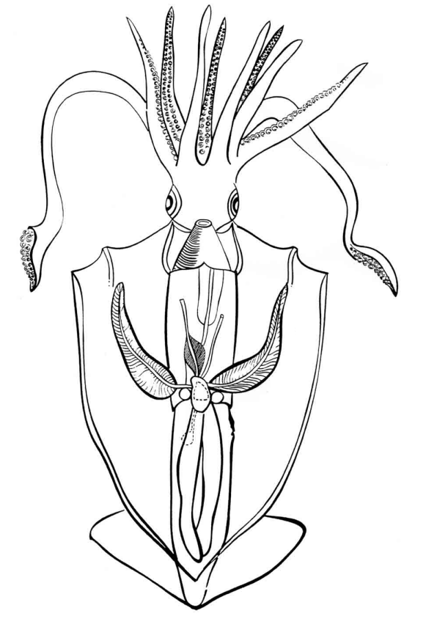

Gills

Guts (visceral mass)

Pen

Ink sac

Reproductive organ

**Squid Dissection**

**Date:**

**Partners:**

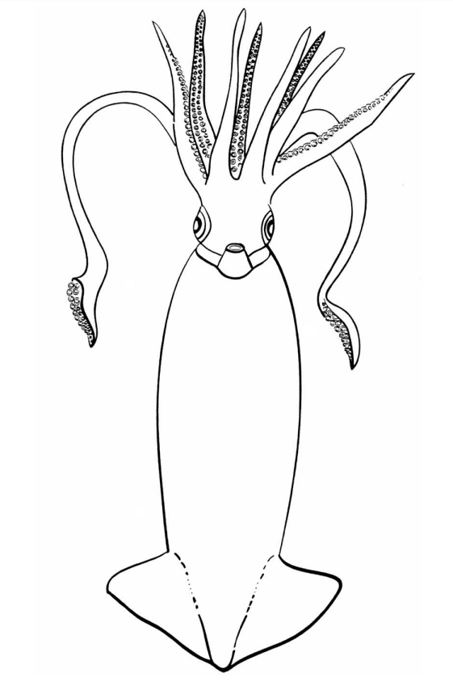

Shape

Fin

Countershading

Mantle

Siphon

Tentacles

Mouth

Beak

eye